Amazon Web Services

**Internet Gateway & Route Table**

# Internet Gateway

* Component that allows communication between our VPC and the internet

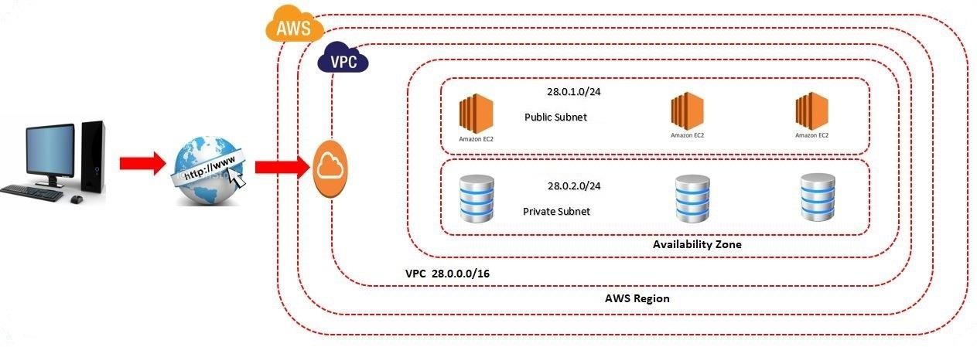

# Internet Gateway

* Click on Internet Gateway
* Click on Create Internet gateway
* Enter the name of the Internet gateway
* Click on Create Internet gateway
* Attach internet gateway to our VPC

# Internet Gateway

* Select our internet gateway

Actions

Attach to VPC

* Select our VPC
* Click on Attach internet gateway
* We need to attach our internet gateway to our Public Subnet.
  + But we can’t attach an internet gateway directly to the public subnet.

# Route Table

* Route table defines rules, termed as routes, which determine where network traffic from the subnet would be routed.

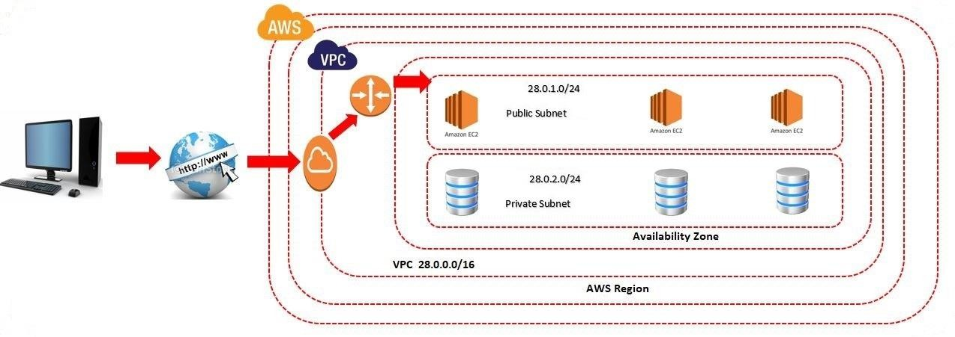

# Route Table

* Click on Route table
* Click on Create route table.
* Enter the Name
* Select the VPC
* Click on Create route table
* Attach Route Table with subnet

# Route Table

* Select our route table

Actions

Edit Subnet Associations

* Select the public subnet
* Click on save Associations
* **Attach Route table with Internet gateway**
* While attaching the route table with internet gateway we need to

provide two elements

* Destination
* Target

# Route Table

* Select the route table

Actions

Edit Routes

* Click on Add route
* Select target as our Internet gateway
* Enter Destination (0.0.0.0/0)
* Click on save changes

# EC2 – Public Subnet

* Create Linux EC2 Machine in Pubic Subnet
* Change network, Subnet & Auto Assign Public IP
* Bootstrap Script Code:

#!/bin/bash

sudo su

yum update -y

yum install httpd -y

cd /var/www/html

echo "AmazonWebservices" > index.html

service httpd start

chkconfig httpd on

* Create Security Group
* Enable the SSH Port to anywhere as source
* Enable the HTTP Port to anywhere as source
* Launch the Instance & Create a new Key Pair

# EC2 – Private Subnet

* Create One More Linux EC2 Machine in Private Subnet

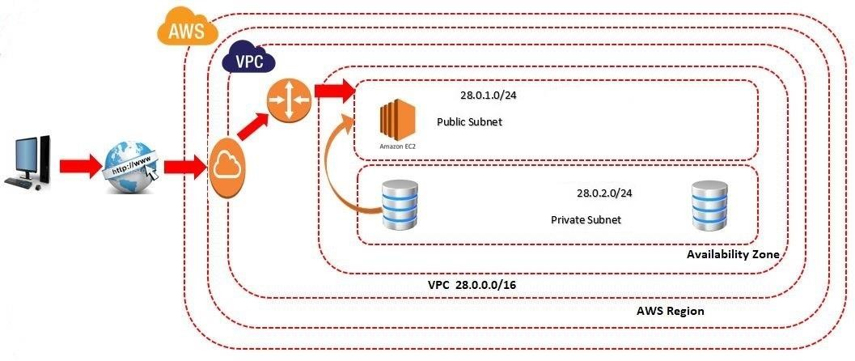

# EC2 – Private Subnet

* Select Our VPC & Private Subnet
* Create Security Group
* Select Type as MYSQL/Aurora & Source as Custom
* Enter Port Number of Public Subnet
* Launch the Instance
* Create a new Key Pair